**Individual Task 2**

**Gadtardi Pratama Wongkaren 2301929480**

**Exercise 1**

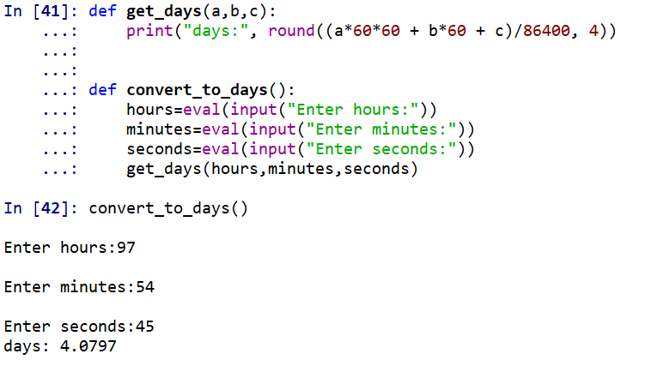

**Exercise 2**

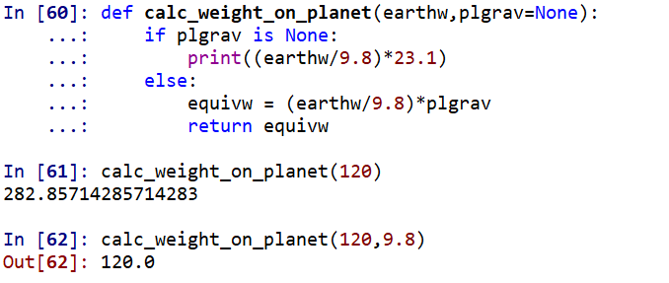

**Exercise 3**

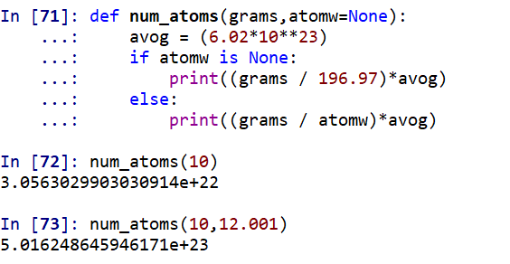

**Exercise 4**

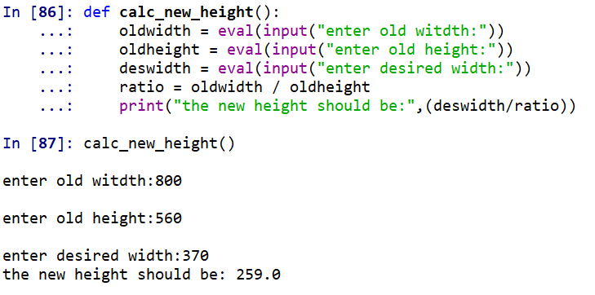

**Exercise 5**